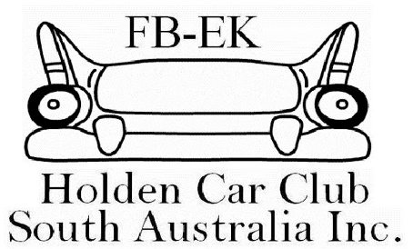
32nd FB-EK Holden Nationals
Nuriootpa, South Australia
11th & 12th June 2022
Hosted by the FB EK Holden Car Club of SA

The FB-EK Holden Car Club of South Australia Inc. are pleased to invite you to the 32nd FB & EK Holden Nationals in and around the township of Nuriootpa, South Australia on the Queen’s Birthday long weekend 11th & 12th June 2022.
Entry is open to all owners of FB – EK Holdens
We are again looking forward in hosting our 3nd Nationals & we hope you enjoy your time in the wonderful Barossa Valley.
We will be centring the Nationals in the township of Nuriootpa, which is 82 km north east of Adelaide in the Barossa Valley.
For those who like a little wine there is a multitude of wineries to visit but also a lot of other places of interest that will surprise you.
We will kick off the weekend with the Meet & Greet on Friday night at the Vine Inn, Nuriootpa.
This is proving to be popular event where you can catch up with friends from across the country.

Saturday morning will have the Sign In and collection of the goodie bags at nearby location.
We will have a couple of options to cruise the valley.

Saturday night will be at the Vine Inn in Nuriootpa where we have dinner and some entertaining activities.
Sunday is the Show and Shine for the cars.
We have again split the Modified category into inline 6 and V formation.

Accommodation option range from caravan parks, B&B cottages, Motel to 5-star luxury.
The link below has 85 options to view
https://www.barossa.com/stay/all_accommodation

Beat Regards,
Roger Beale
President FB-EK Holden Car Club of South Australia.
Any enquires please contact the below.
Roger – 0419 730 177
Anne – 0422 673 410
Richard – 0432 505 997
Email – fbekholdencarclubofsa@gmail.com

